3D Engine Training

I. Create Android Project:
1. TASK: Create Android Project.
2. GUIDE:

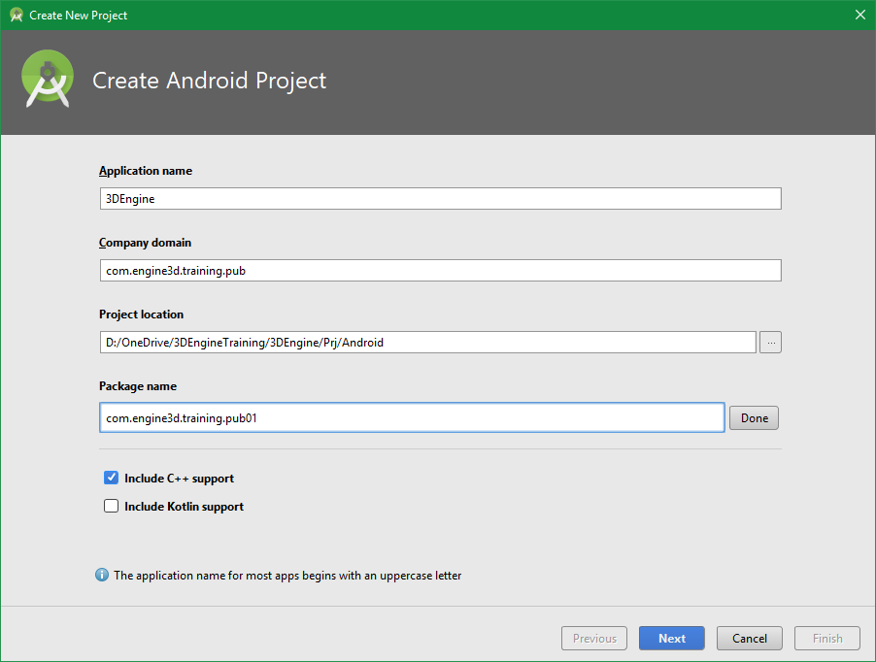
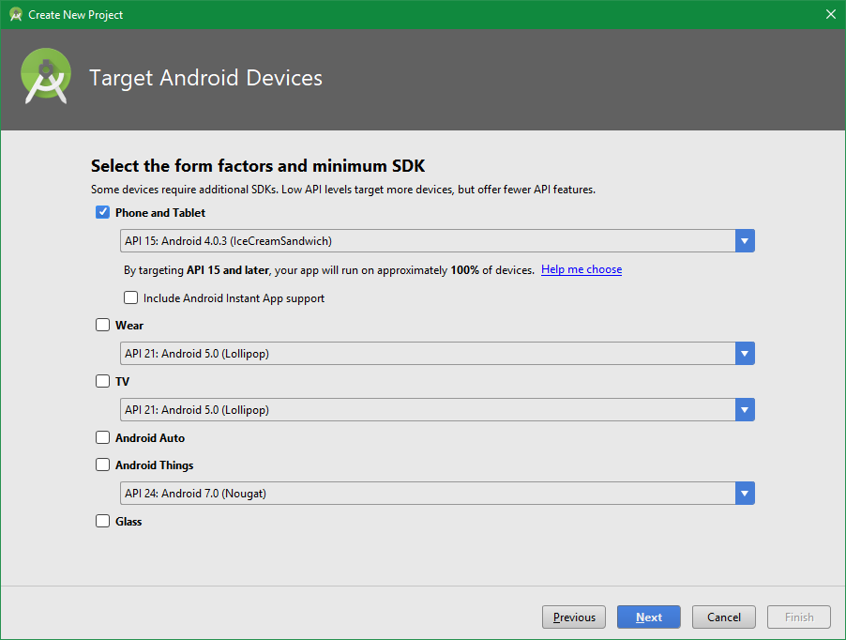
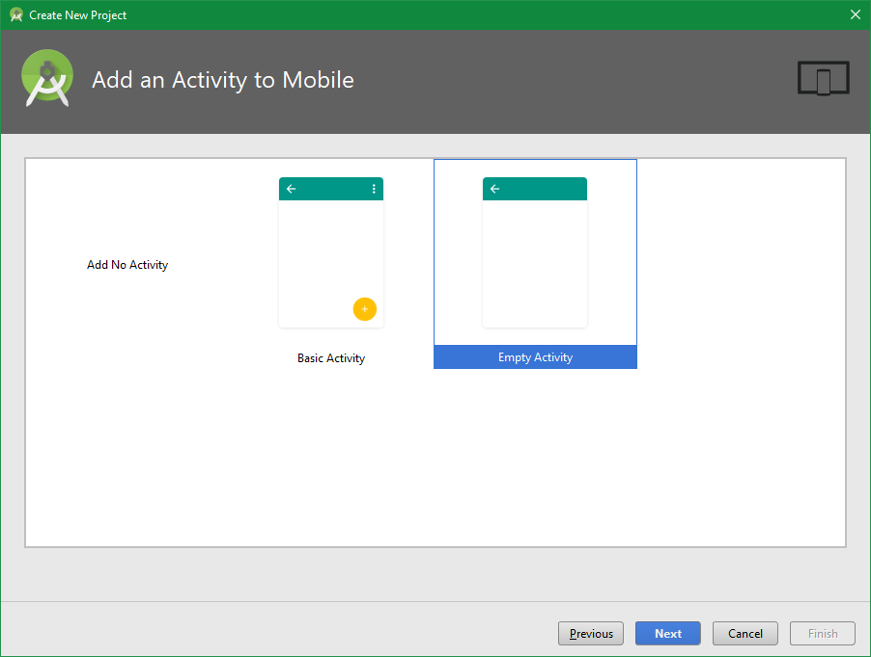

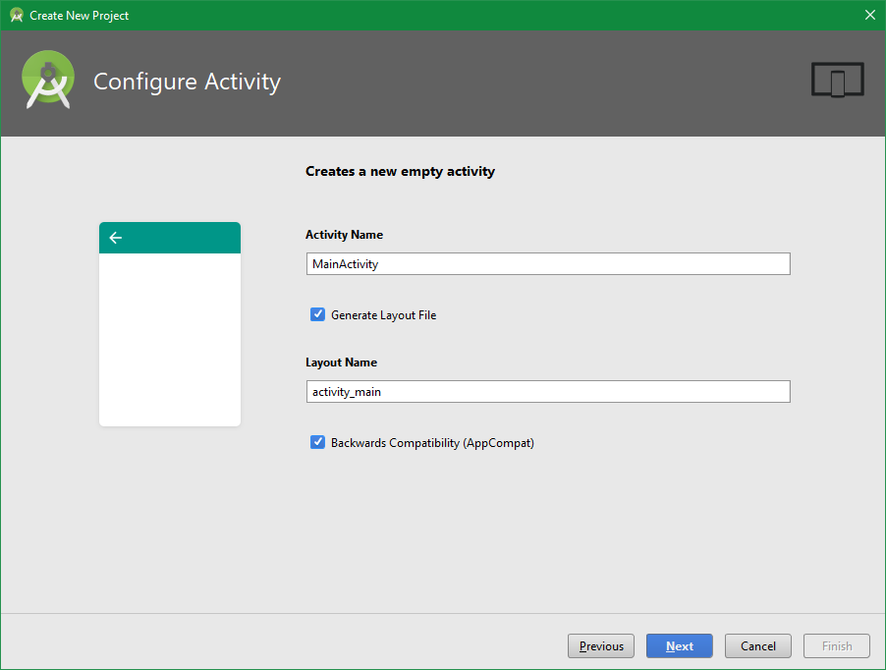
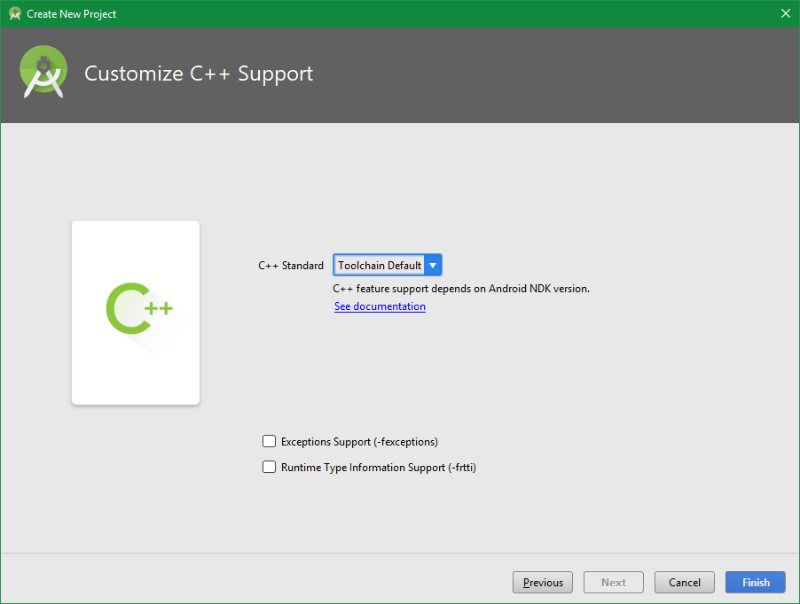

II. Porting from Win32 to Android.
1. TASK:
- Write a JNI function return a string.
- Build .so with Fastbuild.
- Load .so from Java and print the string in Java.
- EX:
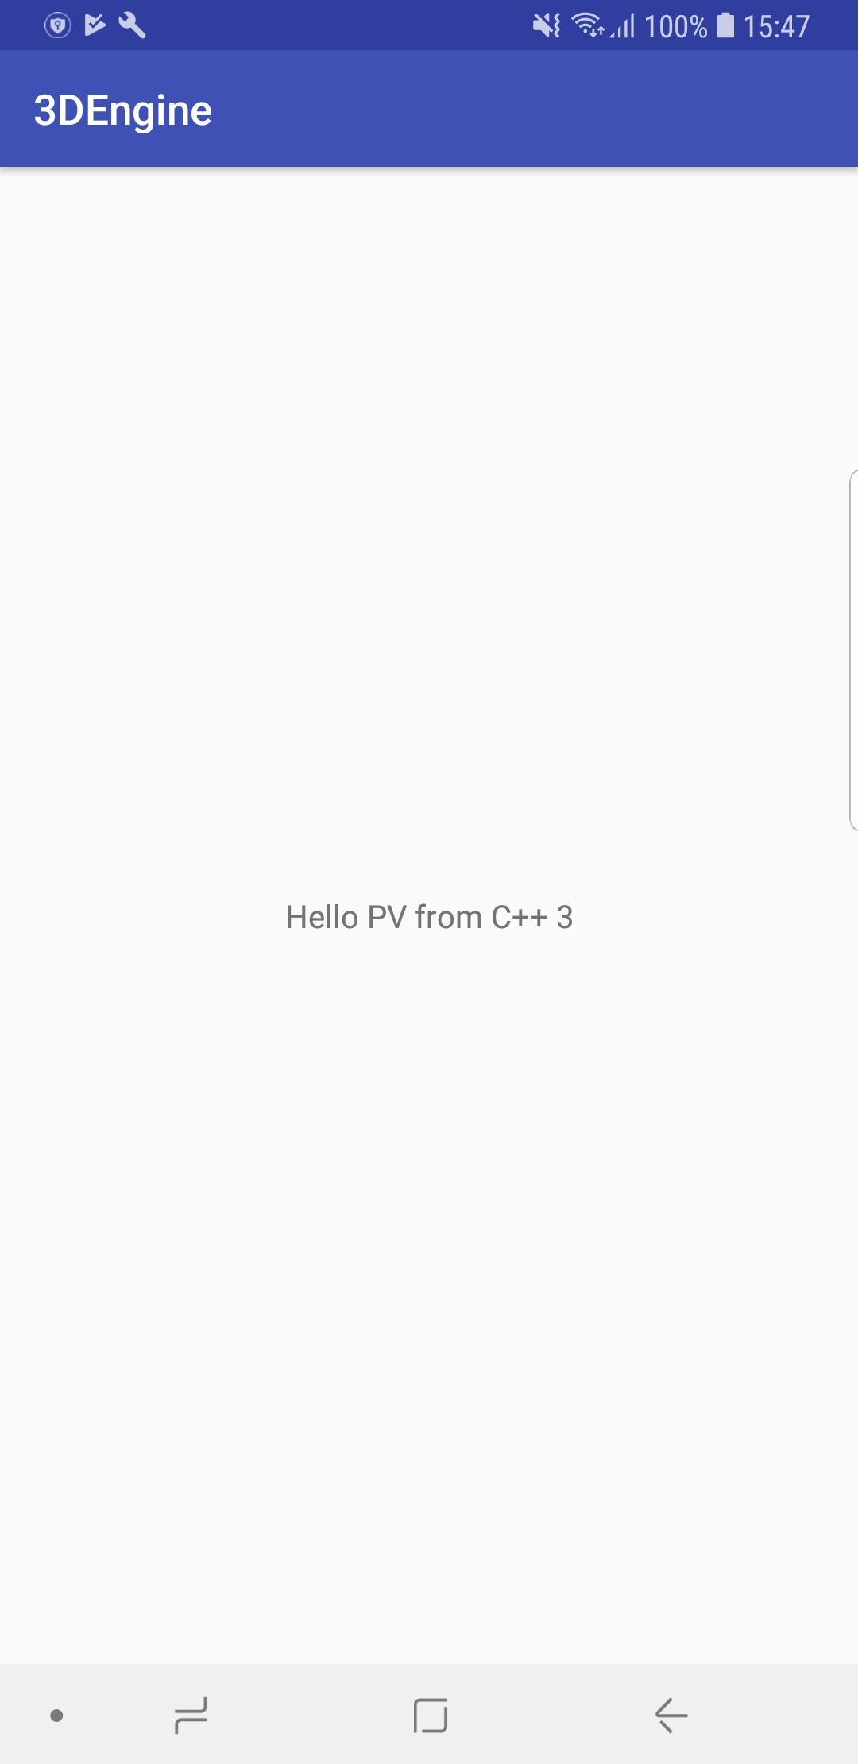
2. GUIDE:
- Create a folder contain JNI files:

- With contain:

- Build "JNIBridge.cpp" into ".o" => link into ".so".
- Load ".so" from Java and print string "std::string hello" from JNI.

